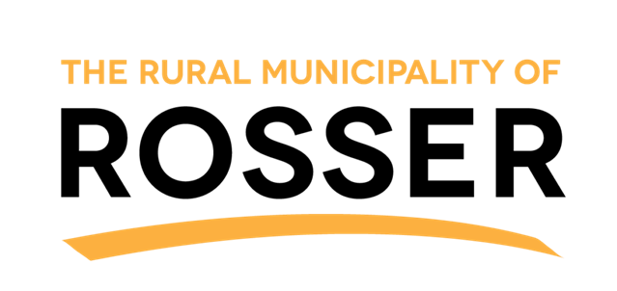
RURAL MUNICIPALITY OF ROSSER
77E PR 221
ROSSER, MB
R4B 0C6
204-467-5571
www.rmofrosser.com

VOTER LIST REGISTRATION

THE UPCOMING GENERAL ELECTION TAKES PLACE ON WEDNESDAY, OCTOBER 28TH 2026. To ensure that all qualified voters of The Rural Municipality of Rosser are registered, please provide the information below for qualified voters in your household. All qualified voters must be:
- A Canadian Citizen; and
- 18 years of Age or older on Election Day; and
- A resident of, or a property owner of, the RM of Rosser as of April 28, 2026.

FIRST NAME | LAST NAME | DATE OF BIRTH  MM/DD/YEAR | PHONE NUMBER | CIVIC ADDRESS | MAILING ADDRESS
Registration can be submitted by eligible voters prior to September 22, 2026 by scanning this completed form and sending to EMAIL: info@rmofrosser.com or by completing this form online at WEBSITE: www.rmofrosser.com

By submitting this document on behalf of my household, I declare all information to be true and accurate, and that each individual named is a qualified voter.

___________________________________ _____________________________
SIGNATURE OF REGISTRANT DATE – MM/DD/YEAR

NAME _____________________________

